|  |  |  |  |  |
| --- | --- | --- | --- | --- |
| توان نامی | سیم­پیچی فشار قوی (HV) | | سیم­پیچی فشار ضعیف (LV) | |
| ولتاژ | جریان | ولتاژ | جریان |
| 100VA | V230 | A0.5 | V115 | A1 |

|  |  |  |  |  |  |  |  |  |  |  |
| --- | --- | --- | --- | --- | --- | --- | --- | --- | --- | --- |
| 100 | 90 | 70 | 60 | 50 | 35.7 | 24.7 | 20 | 9.8 | 3.7 | **V1** |
| 90 | 74 | 54 | 48 | 43 | 35 | 28 | 25 | 18 | 12 | **I1(mA)** |
| 5 | 4.16 | 2.65 | 2.05 | 1.47 | .812 | 0.42 | .275 | .064 | 0.01 | **P1** |
| 187 | 168 | 130 | 113 | 93.5 | 68.4 | 47 | 37.8 | 18.4 | 5 | **V2** |

**جدول 1**

**جدول 2**

|  |  |  |  |  |  |  |  |  |  |  |
| --- | --- | --- | --- | --- | --- | --- | --- | --- | --- | --- |
| 16.5 | 15.46 | 14.10 | 11.94 | 10.21 | 8.07 | 6.24 | 4.13 | 2.20 | 0.25 | **V1** |
| 1 | 0.93 | 0.87 | 0.75 | 0.62 | 0.53 | 0.36 | 0.25 | 0.12 | 0.016 | **I1** |
| 16.29 | 14.14 | 12.27 | 8.77 | 6.39 | 4.15 | 2.32 | 0.99 | 0.27 | 0.004 | **P1** |
| 0.98 | 0.93 | 0.85 | 0.74 | 0.60 | 0.49 | 0.36 | 0.25 | 0.12 | 0.015 | **I2** |

**جدول 3**

|  |  |  |  |  |  |  |  |  |
| --- | --- | --- | --- | --- | --- | --- | --- | --- |
| 569 | 502 | 439 | 377 | 310 | 246 | 183 | 124 | **I1(mA)** |
| 129 | 114 | 99.2 | 85 | 69.4 | 54 | 39.9 | 23.6 | **P1** |
| 114 | 115 | 115 | 116 | 117 | 118 | 119 | 120 | **V2** |
| 1085 | 939 | 809 | 682 | 544 | 408 | 274 | 140 | **I2(mA)** |
| 123 | 107.5 | 93.2 | 79.3 | 63.8 | 48.2 | 32.4 | 16.6 | **P2** |

**جدول 4**

|  |  |  |  |  |  |  |  |  |
| --- | --- | --- | --- | --- | --- | --- | --- | --- |
| 1085 | 939 | 809 | 682 | 544 | 408 | 274 | 140 | **I2(mA)** |
| 95.3 | 94.3 | 93.95 | 93.3 | 91.9 | 89.2 | 81.2 | 70.3 | *(%)η* |

**جدول 5**

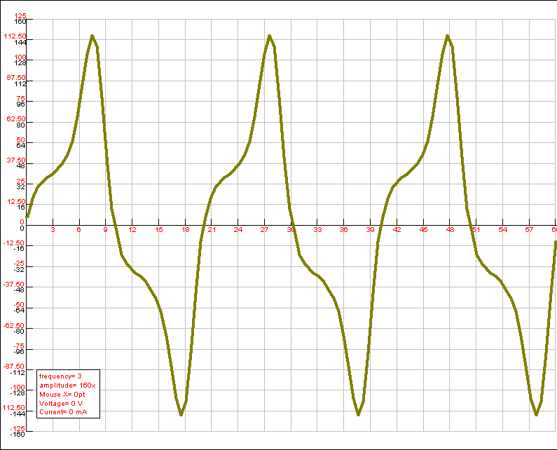

**نمودار 1**

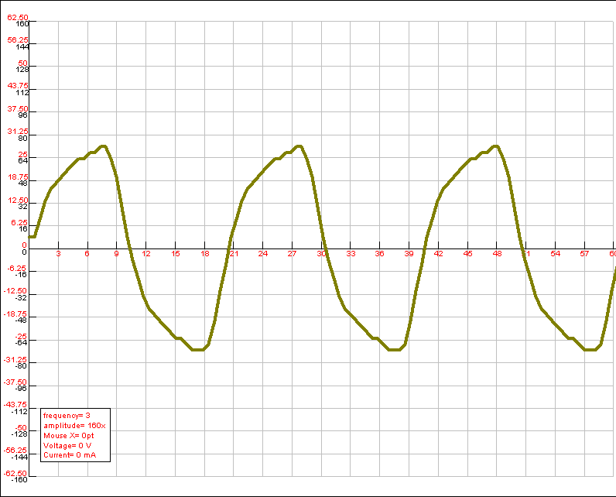

**نمودار 2**

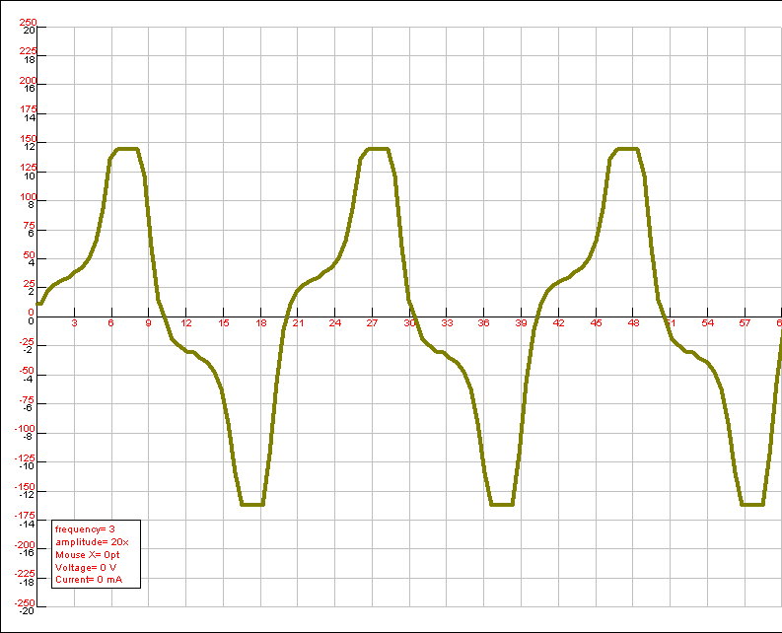

**نمودار 3**

**نمودار ولتاژ ثانویه بر حسب ولتاژ اولیه**

**نمودار 2**

**نمودار توان بر حسب ولتاژ اولیه**

**نمودار 2**

**نمودار جریان اولیه (mA) بر حسب ولتاژ اولیه**

**نمودار 4**

**نمودار 5**